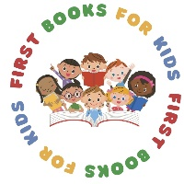
First Books for Kids
Indiana Extension Homemakers Association

Program: First Books for Kids

Sponsored by: The Indiana Extension Homemakers Association through a Volunteer based program

Objective To benefit 3, 4, and 5 year old students in early childhood learning facilities.
(Ex. Head start)

Requirements:

This program only requires 1 (one) hour of participation each selected month from a volunteer. The number of months selected to read are determined by the IEHA County Volunteer coordinator and the facility personnel.

The IEHA Volunteers will join a classroom on a designated day and read a selected story book to the students. At the end of the reading, the volunteer will present a copy of the book read to each of the students in the classroom. The students are then asked to take the gifted book home to share with their family.

The books for this program are purchased by the county organization through fund raising, donations or grants.

Procedure to secure a First Books for Kids Program in a county:
- Select or Appoint a Chair or coordinator
- Contact an early learning facility (ex. Head Start) in your county
- Meet with the facility and discuss IEHA’s participation and the First Books for Kids Program
- Set secured dates with the facility for your volunteers to read
- Recruit reading volunteers
- Purchase Books
- Meet with volunteers for training and explanation of program
- Read
- Send evaluation form to State Chair (address on evaluation form)

Questions:
Jo Almond – Chair/Founder 317-432-5706 jea919@gmail.com

 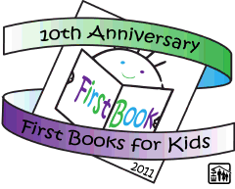 Revised 2025 